A1358-MEX-Mezcala-Temple with Two Columns and Ancestor-300 BCE

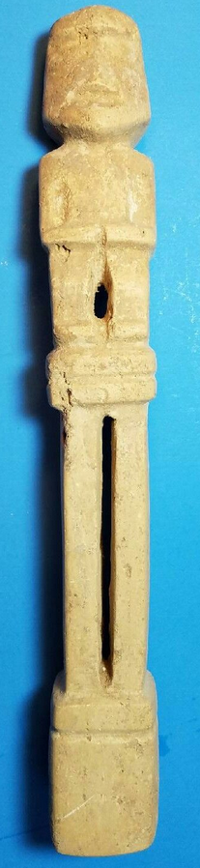  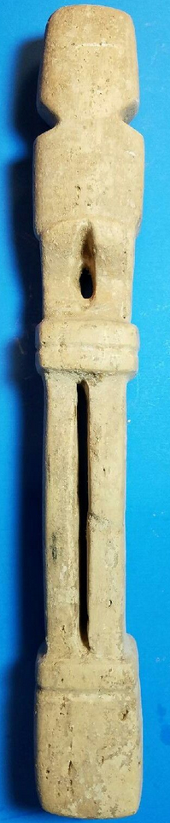 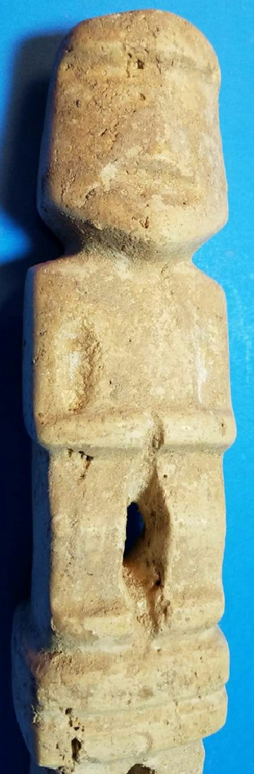

Figs. 1-4. Mezcala-Temple with Two Columns and Ancestor-300 BCE

**Case no.: 14**

**Accession Number: A1358**

**Formal Label:** Mezcala-Temple with Two Columns and Ancestor-300 BCE

**Display Description:**

**LC Classification:**

**Date or Time Horizon:**

**LC Classification**:  [F1219.1.G93](http://luna.wellesley.edu/search~S1?/mF1219.1.G93+G29+1992/mf++1219.1+g93+g29+1992/-3,-1,,B/browse)

**Date or Time Horizon:** Early Preclassic, 300 BCE

**Geographical Area:** Balsas, Guerrero, Mexico

**Map:**

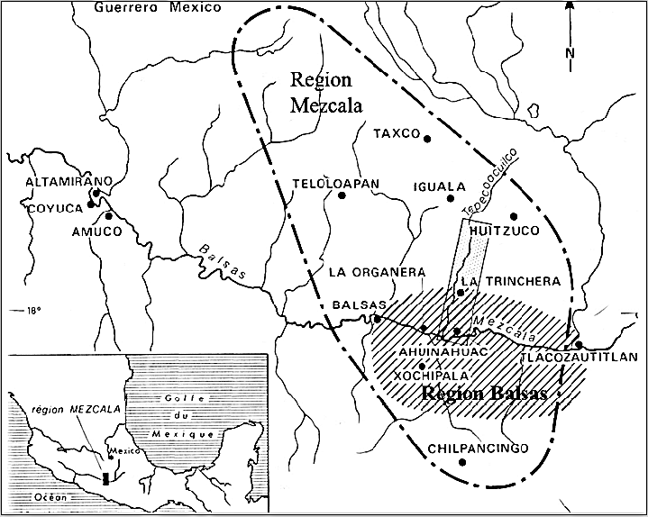

Fig. 2. Map of Guerrero, Mezcala, after <http://www.samildan-art.com>.

**GPS coordinates**: Balsas, Mezcala: 17° 55' 00" N, 102° 10' 00" W

**Cultural Affiliation:** Mezcala

**Cultural Affiliation:**

**Medium:** white calcite

**Dimensions: H** 12 in, W 1.75

**Weight:**

**Condition: original**

**Provenance:**

**Discussion:**

The definition of the Mezcala styles has been diverse. For instance, Carlo Gay (1967) restricted the Mezcala style to schematic objects dating them to the Preclassic Period. Serra (1973) on the other hand, established another classification focused on anthropomorphic representations.

**References:**

**Appendix:**

Temple miniature  
Culture Mezcala  
Etat de Guerrero, Mexique  
Préclassique récent, 300-100 av. J.-C.

MEZCALA STONE MINIATURE TEMPLE, GUERRERO, MEXICO

**Estimate** http://www.sothebys.com/content/dam/default/lotSymbols/symb_DoubleDagger.gif8,000 — 10,000

**LOT SOLD.** 9,375 EUR

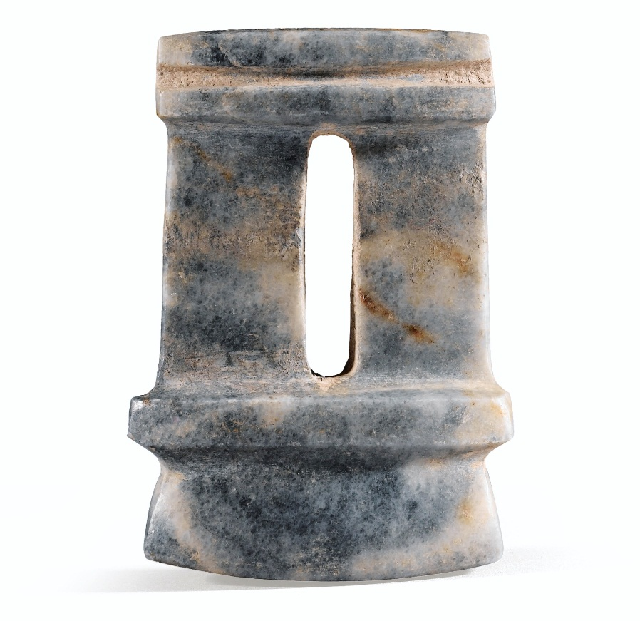

# Collection Barbier-Mueller Art Précolombien

#### 22 March 2013 - 23 March 2013 | 4:00 PM CET

#### Paris

* [Contact Info](http://www.sothebys.com/en/auctions/ecatalogue/2013/collection-barbier-mueller-pf1340/lot.185.html)

Temple miniature  
Culture Mezcala  
Etat de Guerrero, Mexique  
Préclassique récent, 300-100 av. J.-C.

MEZCALA STONE MINIATURE TEMPLE, GUERRERO, MEXICO

http://www.sothebys.com/en/auctions/ecatalogue/2013/collection-barbier-mueller-pf1340/lot.185.html